ZANCO Journal of Pure and Applied Sciences
The official scientific journal of Salahaddin University-Erbil
https://zancojournals.su.edu.krd/index.php/JPAS

ISSN (print ):2218-0230, ISSN (online): 2412-3986, DOI: http://dx.doi.org/10.21271/zjpas
RESEARCH PAPER

STUDY OF ULTRAVIOLET SOLAR RADIATION IN DUHOK CITY UNDER CLEAR SKY CONDITIONS

¹Omar Salih Omar, ²Thabit Elias Basheer
¹ Department of Physics, College of Science, Duhok university, Duhok , Kurdistan Region- Iraq
² Department Environmental Sciences, Faculty of Science, Zakho university, Zakho, Kurdistan Region- Iraq

A B S T R A C T:
This work focused on the UV solar radiation measurements under clear sky conditions for typical days in months (April to July) when the UV radiation is expected to have the highest values in Duhok city.
Two types of UV, (UVA and UVB) were measured from April to July under clear sky conditions. The maximum UVA (wavelength 315-400 nm) irradiance (38 and 37) W/m² was measured at noon in June and July, respectively. The minimum UVA of 30 W/m² was recorded at April noon. In July, the hourly UVA ranged between 2.6 W/m² at 6:00 pm to 37 W/m² at 12:00 pm; maximum UVB (wavelength 280-315 nm) irradiance of 1.9 W/m² was measured in July noon’s, and a minimum of 1.4 W/m² at April noon.
The effect of the atmosphere (solar zenith angle) on the UVB clearness index was investigated and a functional relationship between them was developed. Finally, the time required for UVB minimum erythemal dose was estimated.
KEY WORDS: Clear Sky Conditions, Duhok city, Solar UV radiation
DOI: http://dx.doi.org/10.21271/ZJPAS.34.4.11
ZJPAS (2022) , 34(4);102-107 .

1.INTRODUCTION :

The study of ultraviolet solar radiation has received significant attention across the globe due to its biological and ecological effects (Modenese, Korpinen & Gobba 2018; Vanhaelewyn et al. 2020; Neale et al. 2021; Nicastro et al. 2021). Based on the biological effects, solar UV radiation is classified into three regions UVC (100-280 nm) which is completely absorbed by the ozone layer, UVB (280-315 nm) partially scattered and absorbed by atmospheric gases and UVA (315-400 nm) which comprises most of the solar UV radiation reaching the earth’s surface (Lerche, Philipsen & Wulf 2017).

* Corresponding Author:
Omar Salih Omar
E-mail: omar_dosky@uod.ac
Article History:
Received: 11/04/2022
Accepted: 23/05/2022
Published: 15/08 /2022

There are many factors affecting the amount of solar UV radiation reaching the earth such as the earth-sun distance, solar zenith angle, clouds, atmospheric gasses, the presence of dust particles in the atmosphere, and the surface albedo (Bais et al. 2019). The amount of solar radiation reaching the top of the atmosphere is inversely proportional to the square distance between the sun and the earth. The intensity of the UV solar radiation decreases as the solar zenith angle increases because the incident falling radiation is proportional to the cosine of the angle between incident rays and the horizontal surface. The heavy cloud coverage could scatter up to 95% of the incident solar UV radiation. The atmospheric gases such as Ozone, Sulphur dioxide, and nitrogen dioxide absorb a significant portion of UV solar radiation. The surface albedo, especially in snowing-covered areas, reflects UV solar radiation into the atmosphere. The atmospheric aerosols also absorb and scatter UV radiation. Both scattering and absorption are inversely proportional to the UV wavelength (Kerr 2005).
Biologically, UV solar radiation could have both benefits and adverse effects. On the one hand, excessive exposure to UV solar radiation could cause many health issues, it could affect the eye's dioptric system and retina (Ivanov et al. 2018). The immune system could also be affected by UV, it might decrease the body's ability to resist infectious diseases (Bernard, Gallo & Krutmann 2019). It is also the most important environmental risk factor for developing non-melanoma skin cancer, especially in the summer months when the solar zenith angle is low (Snyder et al. 2020). On the other hand, a lack of UV exposure might result in vitamin D deficiency. Vitamin D deficiency could cause serious health problems. Different types of cancer, bone diseases, autoimmune diseases, infectious diseases, hypertension, and cardiovascular disease have been associated with vitamin D deficiency (Young et al. 2021). Moreover, excessive exposure to UV radiation could damage polymeric materials, solar cells, paints, and ecosystems. For example, it accelerates the photo degeneration of solar cells, limiting their mean lifetimes (Andrady, Hamid & Torikai 2011).
Each UV wavelength has a different power to cause an effect on humans and animals. Shorter wavelengths have higher biological effects. The relative strength of each wavelength can be determined by the action spectrum functions. Although the global UV irradiance on earth is approximately 94% UVA and only 6% UVB, the erythemal weighted irradiance is just 17% UVA and 83% UV-B (Van Geffen et al. 6-10 September 2004; Bilbao & de Migue 2020).
To our best knowledge, there is no measured UV solar radiation for Duhok city. The importance and interest of this work are that similar data series had not been recorded before and no similar work has previously been done in Duhok province. Therefore, it is crucial that this data needs to be introduced and the importance of UV radiation be recognized.
2. MATERIALS AND METHODS
The study was performed in Duhok city in the Kurdistan region of Iraq. Duhok is located in the northwest of Iraq and the western part of the Kurdistan region, (latitude 36°5′N, longitude 43° E).
According to the Ministry of Health of Iraq statistics, skin cancer is the second top ten cancer incidence in Duhok (10.8%) of all cancer cases and (6.6) per 100,000 populations. From a health perspective, the significance of this study is crucial because there is no information about UV solar measurements in Duhok.
As there is no ground database in Duhok for measuring UV solar radiation, the measurement of UV solar radiation was achieved manually by UVA (315-400 nm) and UVB (280-315 nm) portable sensors manufactured by PHYWE company. The hourly data was collected at Duhok city center from 2009 to 2010.
The intensity of the UVB radiation on the earth’s surface strongly depends on the solar zenith angle, which is defined as the angle between the incident rays and a horizontal surface. At low zenith angles (around sunrise and sunset), the UVB photon travels along a path through the ozone layer and the air column in the atmosphere increasing the probability of the attenuation and scattering and subsequently reducing the UVB intensity. The hemispherical transmittance (Kt) or clearness index is defined as the ratio of the UVB radiation on a horizontal surface to the extraterrestrial UVB intensity(Iqbal 1983):
$$Kt=\frac{I\left(UVB\right)}{I\left(UVBext\right)} \left(1\right)$$
Where I (UVB) and (UVBext) are the terrestrial and extraterrestrial UVB intensities respectively.
The solar Io (UBVext) is the average amount of UVB solar radiation per unit time per unit area falling on a surface perpendicular to the sun rays outside the atmosphere of the earth (extraterrestrial) at mean sun-earth distance (one astronomical unit). The measured value of the solar constant at a mean sun-earth distance is found to be I_{o} (UVB_{ex}t)=21.51 W/m² (Iqbal 1983). While the distance between the earth and the sun varies as the earth moves around the sun on its elliptical orbit. The instantaneous value of the solar constant can be computed from the following equation:
$$I_{\left(UVB\right)ext=}I_{o}{\left(\frac{L_{o}}{L}\right)}^{2} \left(2\right)$$
Where L is the instantaneous sun-earth distance, Lo is the mean sun-earth distance (Lo= 1.49×10¹³m) and (L_{o}/L) ² is called the eccentricity correction factor, which is given by:
$${\left(\frac{L_{o}}{L}\right)}^{2}=1+0.003\operatorname{co}{s\left(\frac{360D}{365}\right)} \left(3\right)$$
Where D is a day number.
In terms of solar zenith angle (θ) (The hourly variation):
$$I_{\left(UVB\right)ext}\left(t\right)=I_{\left(UVB\right)ext}\cos\left(θ\right) \left(4\right)$$
Combining equations (2, 3, and 4), the hourly variation of extraterrestrial UVB solar radiation can be found as follow: $I_{\left(UBV\right)ext}(t)=I_{o}(1+0.003\cos\left(\frac{360D}{365}\right))cos\left(θ\right) (5)$

3. RESULTS
The UVA and UVB radiation measurements were done every hour from 1 April to 31 July under clear sky conditions. The hourly and daily variations of UVA and UVB in Duhok city are presented and the results are discussed. The study period is chosen because solar UV radiation is expected to have the highest values. The solar zenith angle is the lowest during this month and the sunshine duration is the highest (Salahaldin Na’man, Haval Y. Yacoob and Omar S. Omar 2013)
Duhok is located in the north part of the Iraq-Kurdistan Region with coordinates (36.8679° N, 42.9489° E). It is clear from Figure 1 that the maximum values of UVA irradiance during the peak hour (about12:00 PM) were recorded for June and July. The values of 38 and 37 W/m² were measured for these two months respectively. These values are much lower than that recorded for the southern cities of Iraq, for example, the value of 50.1 W/m² was recorded for Baghdad during the same period of the year (Alsalihi & Abdulatif 2016). The lowest value of UVA recorded at the peak hour during this study was 30 W/m² in April. As one can see, there are sharp variations in hourly recorded values of UVA irradiance during the day. For example, in June in the early morning, the value of UVA irradiance is 4.5 W/m², this value rises to 38 W/m² at noon, then falls to only 2 W/m² in the late afternoon. There is a direct relationship between the sun's elevation and the level of UV radiation. The higher the sun in the sky, the higher the amount of solar UV radiation reaching the ground. There is a dramatic increase in the UV level during the day as the sun rises and around 60% reaches the ground between 11 and 14 o’clock. This is mostly due to the less attenuation and scattering of the UV by the atmosphere (Webb & Engelsen 2006). The same patterns of hourly variations of UVA irradiance can happen during all months.
The UVB irradiance values in Duhok city are presented in Figure 2 similar to UVA, the maximum values of UVB were recorded for June and July. The values of 1.8 and 1.9 W/m² were recorded at the peak hours for June and July respectively. The lowest value of 1.44 W/m² was recorded in April.
The hourly variation of UVB is from 1.9 W/m² at noon down to 0.19 W/m² in the late afternoons as shown for July. These findings are comparable with the ones recorded for Baghdad (Alsalihi & Abdulatif 2016).The amount of UVA is much higher than UVB, the ratio of UV-B irradiance to UV-A irradiance for a typical cloudless day (20th May 2009) is shown in Figure 3. The UVB/UVA ratio ranges from 0.028 to 0.062 and has maximum values around noon. The values for sunrise and sunset are lower; especially there is a drastic decrease at sunset. This might be explained by the longer path for UV solar radiation in the mornings and evenings in combination with the attenuation of UVB by atmospheric gases and greater scattering of shorter UVB wavelengths. Additionally, in the evenings, Duhok city air becomes highly polluted by the car and emergency electric generators smoke, which might cause more scattering of UVB radiation than clean morning air.
The dependence of the clearness index of UVB on the solar zenith angle (SZA) is shown in Figure 4. It can be seen that UVB clearness linearly decreases with increased solar zenith angle. The hourly UVB radiation and clearness are ranging from 0.0023 to 0.09 for low (sunrise and sunset) and high (mid-day) solar zenith angles, respectively. This means that the UVB received by the earth's surface is 0.23% to 9%. To quantify this relationship, a linear regression was tried to find the fit line between both components. The relation between KtUVB and SZA is:
$$K_{t\left(UBV\right)}=0.10475-0.00132θ \left(6\right)$$

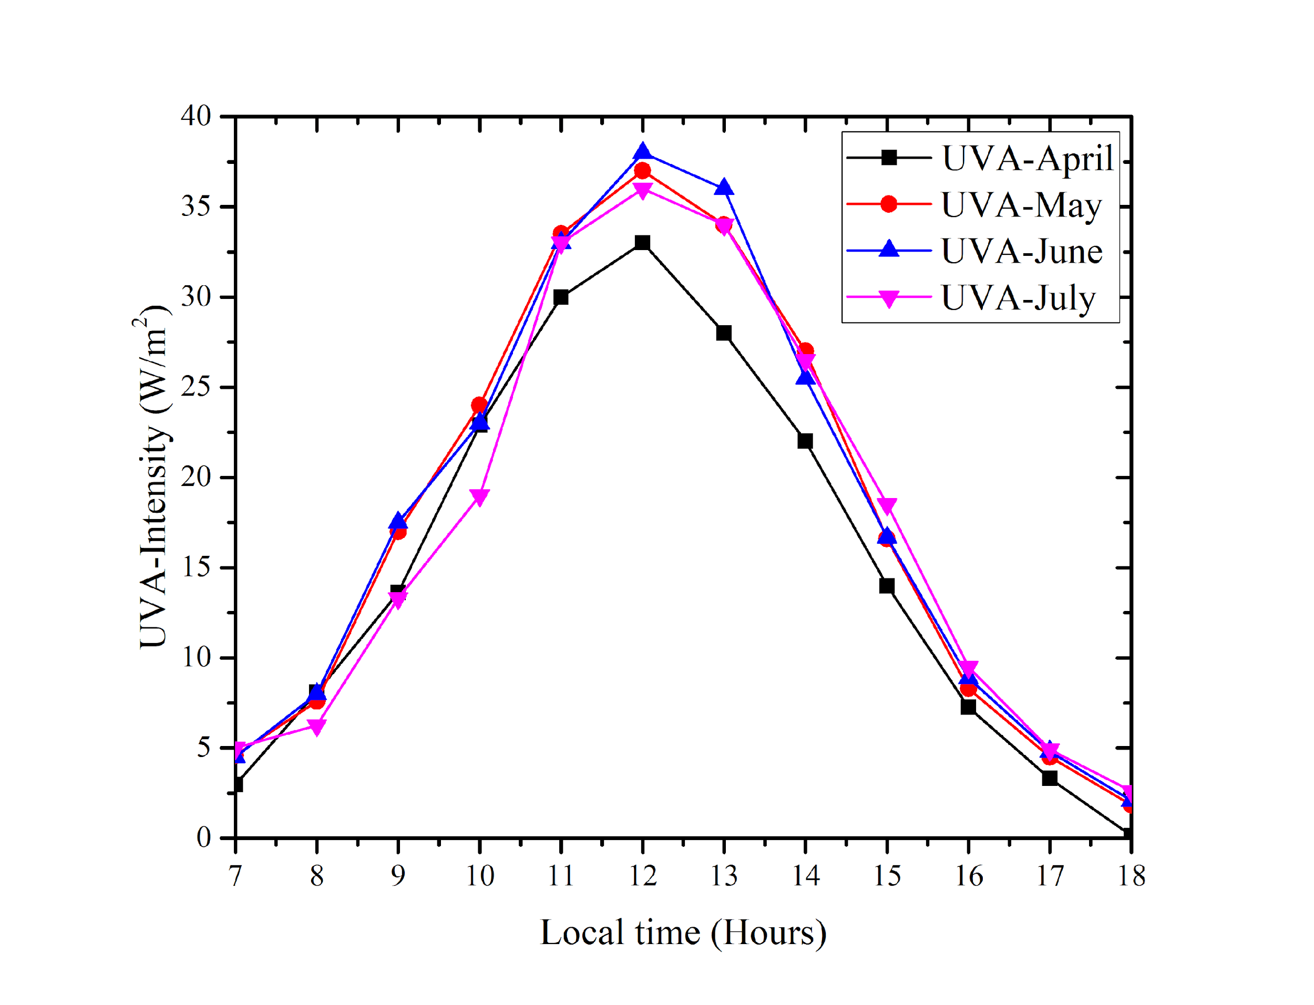
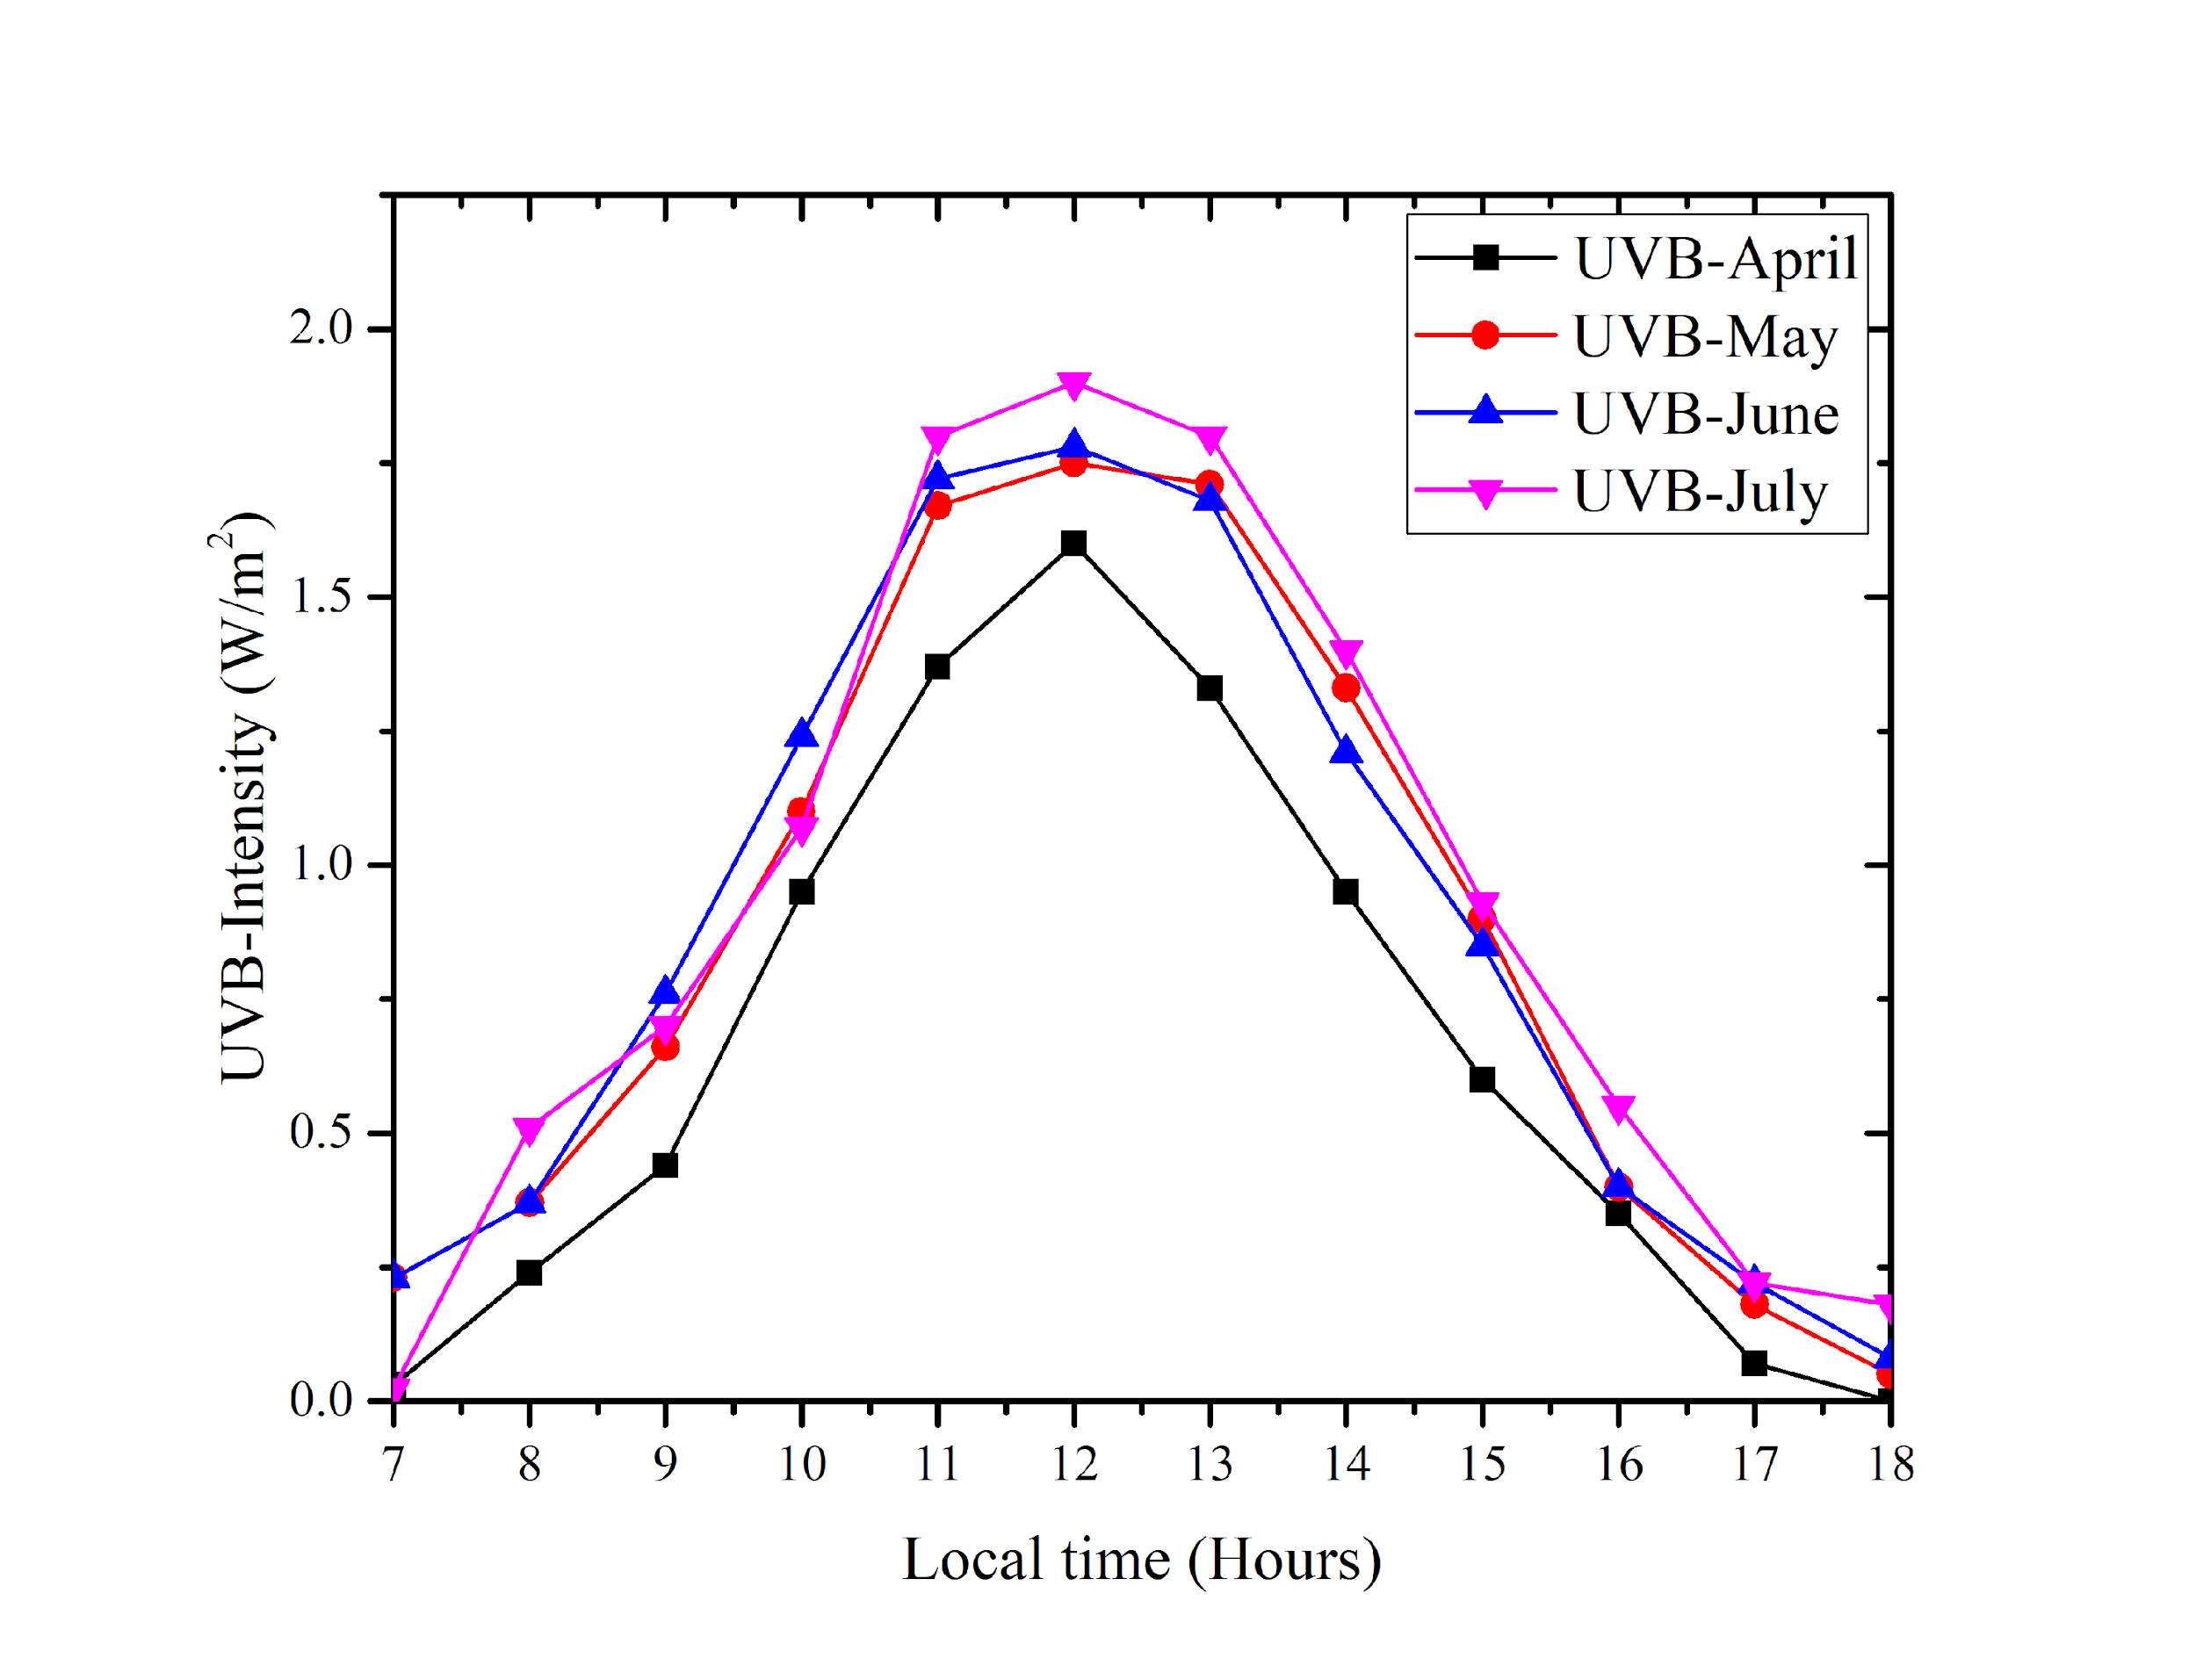
Figure 1: Hourly variation of solar UVA radiation under clear sky in Duhok city.
Figure 2: Hourly variation of solar UVB radiation under clear sky in Duhok city.

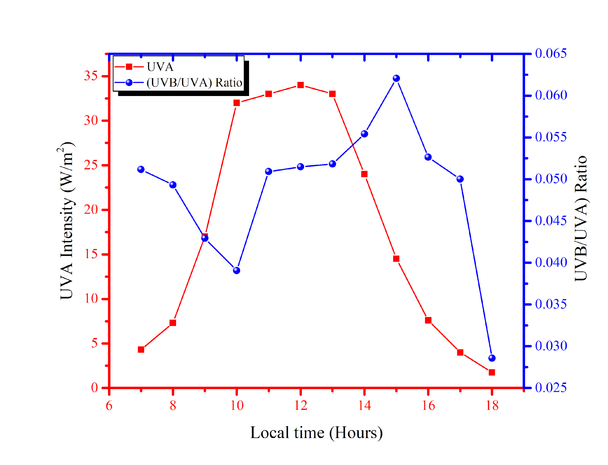
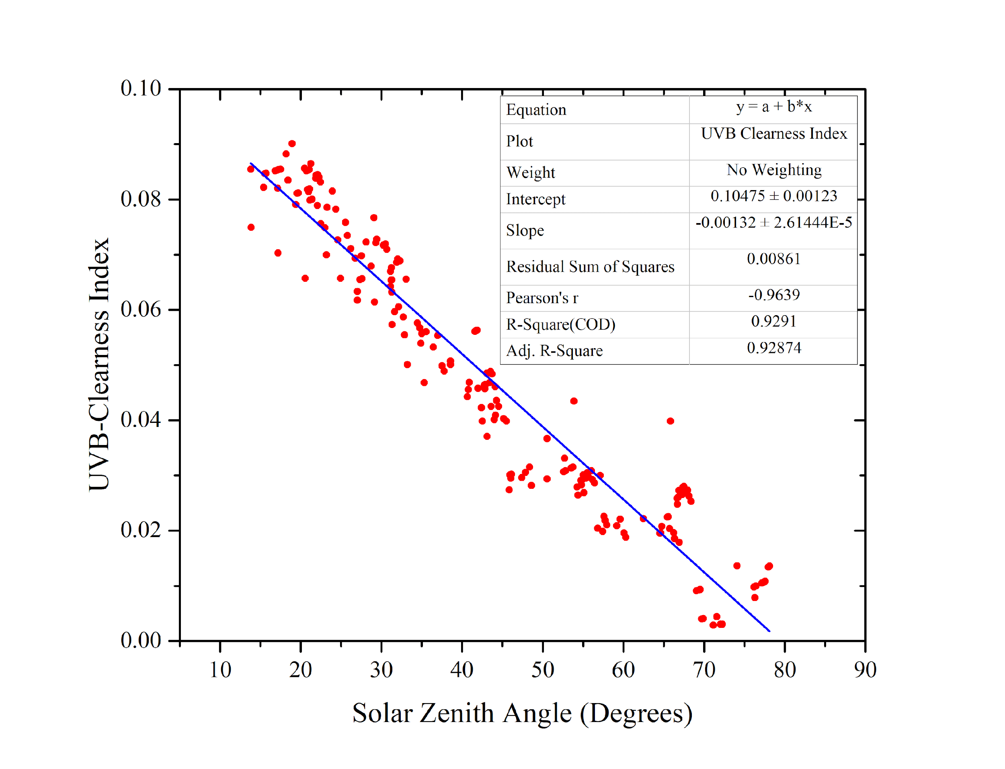
Figure 3: Hourly variation of UVA radiation on (20th May, 2009) (Red line). The ratio of UVB to UVA on the same day (blue line).
Figure 4: UBV clearness as function solar zenith angle under clear sky in Duhok city

4. DISCUSSION
Balancing between the positive and negative effects of solar UV exposure is still controversial. On one hand, overexposure to solar UV radiation is considered one of the most important factors for developing skin cancer. Thus, UV protection is crucial to avoid such malignancies. On the other hand, the vitamin needed for the human body is produced in the skin via exposure to UV radiation (Reichrath 2020). Because DNA can absorb UV wavelengths up to
320nm, most health issues associated with UV exposure come from short wavelengths lying in the UVB broadband. The UV erythemal curve has a maximum from 290 to 300 nm then dramatically falls to almost zero at 320 nm. Accordingly, this part of the UV radiation is efficient (Cadet & Douki 2018). The minimum erythemal dose is defined as the least amount of UV radiation that causes reddening and inflammation on a single individual’s previously unexposed skin (Salvadori et al. 2019). The required period for minimal UV erythemal dose (MED) depends on the solar UV radiation intensity, which is associated with the geographical location, and atmospheric conditions. Using broadband UVB, Yu-Wan Li Chia and Yu Chu (Li & Chu 2007), have found that (MED= 148.3 mJ/cm²) for (Mediterranean, Asian) people who have almost similar skin to Duhok residents. Table (1) shows the minimum MED time for Duhok residents when using measured broadband UVB data at day peak hours (between 11:00 am to 2:00 pm).

Table (1): MED exposure time for April to July at UV peak hours for Duhok residents
Month  Daytime | April  Time (minutes) | May  Time (minutes) | Jun  Time (minutes) | July  Time (minutes)
11:00 am | 18 | 14 | 14 | 13
12:00 pm | 15 | 14 | 13 | 13
1:00 pm | 18 | 14 | 14 | 13
2:00 pm | 26 | 18 | 20 | 17

5.CONCLUSION
During this study, UVA and UVB had maximum values in June and July, while minimum values were in April days. High levels of UVB during the summer months could hurt human life. Therefore, people who have been exposed to UVB solar radiation in their leisure time and outdoor workers should have enough protection (sunscreen) against UV at peak hours during summer days and not be exposed to direct sunlight for more than 15 minutes.
The UVB clearness index decreases as the solar zenith angle increases and a linear relationship are established between them. This relationship can be used to estimate the amount of UVB solar radiation under clear sky conditions reaching Duhok city at any time of the year.
Conflicts of Interest: The authors declare that they have no conflicts of interest to report regarding the present study.

REFERENCES

Alsalihi, A.M. & Abdulatif, S.H., 2016, “Analysis global and ultraviolet radiation in Baghdad City, Iraq,” Analysis, 6(22), 117–124.
Andrady, A.L., Hamid, H. & Torikai, A., 2011, “Effects of solar UV and climate change on materials,” Photochemical & photobiological sciences: Official journal of the European Photochemistry Association and the European Society for Photobiology, 10(2), 292–300.
Bais, A.F., Bernhard, G., McKenzie, R.L., Aucamp, P.J., Young, P.J., Ilyas, M., Jöckel, P. & Deushi, M., 2019, “Ozone-climate interactions and effects on solar ultraviolet radiation,” Photochemical & photobiological sciences: Official journal of the European Photochemistry Association and the European Society for Photobiology, 18(3), 602–640.
Bernard, J.J., Gallo, R.L. & Krutmann, J., 2019, “Photoimmunology: how ultraviolet radiation affects the immune system,” Nature reviews. Immunology, 19(11), 688–701.
Alsalihi, A.M. & Abdulatif, S.H., 2016, “Analysis global and ultraviolet radiation in Baghdad City, Iraq,” Analysis, 6(22), 117–124.
Andrady, A.L., Hamid, H. & Torikai, A., 2011, “Effects of solar UV and climate change on materials,” Photochemical & photobiological sciences: Official journal of the European Photochemistry Association and the European Society for Photobiology, 10(2), 292–300.
Bais, A.F., Bernhard, G., McKenzie, R.L., Aucamp, P.J., Young, P.J., Ilyas, M., Jöckel, P. & Deushi, M., 2019, “Ozone-climate interactions and effects on solar ultraviolet radiation,” Photochemical & photobiological sciences: Official journal of the European Photochemistry Association and the European Society for Photobiology, 18(3), 602–640.
Bernard, J.J., Gallo, R.L. & Krutmann, J., 2019, “Photoimmunology: how ultraviolet radiation affects the immune system,” Nature reviews. Immunology, 19(11), 688–701.
Bilbao, J. & Migue, A. de, 2020, “Erythemal Solar Irradiance, UVER, and UV Index from Ground-Based Data in Central Spain,” NATO Advanced Science Institutes series E: Applied sciences, 10(18), 6589.
Cadet, J. & Douki, T., 2018, “Formation of UV-induced DNA damage contributing to skin cancer development,” Photochemical & photobiological sciences: Official journal of the European Photochemistry Association and the European Society for Photobiology, 17(12), 1816–1841.
Iqbal, M., 1983, An Introduction to Solar Radiation, Elsevier.
Ivanov, I.V., Mappes, T., Schaupp, P., Lappe, C. & Wahl, S., 2018, “Ultraviolet radiation oxidative stress affects eye health,” Journal of biophotonics, 11(7), e201700377.
Kerr, J.B., 2005, “Understanding the factors that affect surface ultraviolet radiation,” Optical engineering (Redondo Beach, Calif.), 44(4), 041002.
Lerche, C.M., Philipsen, P.A. & Wulf, H.C., 2017, “UVR: sun, lamps, pigmentation and vitamin D,” Photochemical & photobiological sciences: Official journal of the European Photochemistry Association and the European Society for Photobiology, 16(3), 291–301.
Li, Y.-W. & Chu, C.-Y., 2007, “The minimal erythema dose of broadband ultraviolet B in Taiwanese,” Taiwan yi zhi [Journal of the Formosan Medical Association], 106(11), 975–978.
Modenese, A., Korpinen, L. & Gobba, F., 2018, “Solar radiation exposure and outdoor work: An underestimated occupational risk,” International journal of environmental research and public health, 15(10).
Neale, R.E., Barnes, P.W., Robson, T.M., Neale, P.J., Williamson, C.E., Zepp, R.G., Wilson, S.R., Madronich, S., Andrady, A.L., Heikkilä, A.M., Bernhard, G.H., Bais, A.F., Aucamp, P.J., Banaszak, A.T., Bornman, J.F., Bruckman, L.S., Byrne, S.N., Foereid, B., Häder, D.-P., Hollestein, L.M., Hou, W.-C., Hylander, S., Jansen, M.A.K., Klekociuk, A.R., Liley, J.B., Longstreth, J., Lucas, R.M., Martinez-Abaigar, J., McNeill, K., Olsen, C.M., Pandey, K.K., Rhodes, L.E., Robinson, S.A., Rose, K.C., Schikowski, T., Solomon, K.R., Sulzberger, B., Ukpebor, J.E., Wang, Q.-W., Wängberg, S.-Å., White, C.C., Yazar, S., Young, A.R., Young, P.J., Zhu, L. & Zhu, M., 2021, “Environmental effects of stratospheric ozone depletion, UV radiation, and interactions with climate change: UNEP Environmental Effects Assessment Panel, Update 2020,” Photochemical & photobiological sciences: Official journal of the European Photochemistry Association and the European Society for Photobiology, 20(1), 1–67.
Nicastro, F., Sironi, G., Antonello, E., Bianco, A., Biasin, M., Brucato, J.R., Ermolli, I., Pareschi, G., Salvati, M., Tozzi, P., Trabattoni, D. & Clerici, M., 2021, “Solar UV-B/A radiation is highly effective in inactivating SARS-CoV-2,” Scientific reports, 11(1), 14805.
Reichrath, J., 2020, “Lessons learned from Paleolithic models and evolution for human health: A snap shot on beneficial effects and risks of solar radiation,” Advances in experimental medicine and biology, 1268, 3–15.
Salahaldin Na’man, Haval Y. Yacoob and Omar S. Omar, 2013, “Optimum Tilt Angle for South Facing Flat Solar Collectors in Duhok City,” Science Journal of University of Zakho, 1(1), 405–413.
Salvadori, G., Lista, D., Burattini, C., Gugliermetti, L., Leccese, F. & Bisegna, F., 2019, “Sun exposure of body districts: Development and validation of an algorithm to predict the erythemal Ultra Violet dose,” International journal of environmental research and public health, 16(19), 3632.
Snyder, A., Valdebran, M., Terrero, D., Amber, K.T. & Kelly, K.M., 2020, “Solar ultraviolet exposure in individuals who perform outdoor sport activities,” Sports medicine - open, 6(1), 42.
Van Geffen, J., Van Der A, R., Van Weele, M., Allaart, M. & Eskes, 6-10 September 2004, “Surface UV radiation monitoring based on GOME and SCIAMACHY,” Proceedings of the 2004 Envisat & ERS Symposium, Salzburg, Austria, 572(1073-1082,), 1073–1082.
Vanhaelewyn, L., Van Der Straeten, D., De Coninck, B. & Vandenbussche, F., 2020, “Ultraviolet radiation from a plant perspective: The plant-microorganism context,” Frontiers in plant science, 11, 597642.
Webb, A.R. & Engelsen, O., 2006, “Calculated ultraviolet exposure levels for a healthy vitamin D status,” Photochemistry and photobiology, 82(6), 1697–1703.
Young, A.R., Morgan, K.A., Harrison, G.I., Lawrence, K.P., Petersen, B., Wulf, H.C. & Philipsen, P.A., 2021, “A revised action spectrum for vitamin D synthesis by suberythemal UV radiation exposure in humans in vivo,” Proceedings of the National Academy of Sciences of the United States of America, 118(40), e2015867118.

